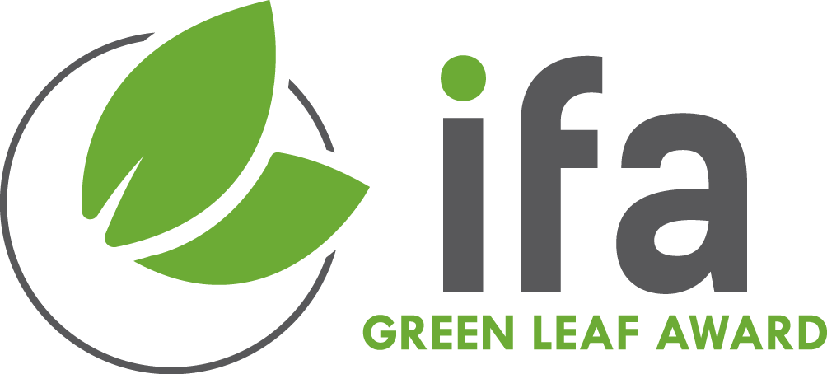

2024 IFA Green Leaf Award
for Excellence in Safety, Health and the Environment in Fertilizer Production

Applications should be submitted to Alexandra Dorison of the IFA Secretariat by
31 January 2024

Production complex / unit (single site)

Production site / unit:
Company:
Main contact:
Address:

Tel:
E-mail:
Web:

1. Business Profile (not more that 500 words):

2. Description of the Case Study (not more than 1000 words):

Describe the plant’s approach to improving SHE performance:

3. Supporting Evidence/Proof (no more than 500 words):

Please note: you should provide relevant SHE records, such as total recordable injuries, environmental performance, and sickness rate records by separate attachment.

